GDAPS2 – Practice Exercise

Graph Basics

Objective
Practice setting up and using graph data structures with a simple console application.

Details
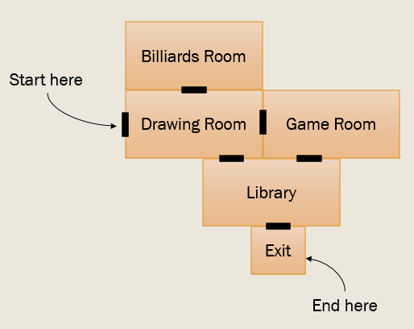
Graphs are an abstract way of representing connections between things. They commonly appear in games to represent areas that are reachable from other areas, and for the purposes of AI & pathfinding. They have many other applications in advanced algorithms as well.

Your program will repeatedly list the rooms adjacent to the player’s current room and ask which room the player would like to visit next. Upon reaching the exit, the program will end.

The example “map” of rooms to the right would result in the following output:

You are currently in the DRAWING ROOM: In this room, you can draw stuff.
Nearby are: billiards room game room library
Where would you like to go? library

You are currently in the LIBRARY: An entire room full of books.
Nearby are: drawing room game room exit
Where would you like to go? afafefef

Sorry, that is not an adjacent room.
Where would you like to go? exit

You have successfully escaped.
Press any key to continue. . .

Your Map
For this exercise, your room layout must match the example image above. You may add extra rooms if you wish, but the five rooms from the image above, and their relationships, must be present.

Vertex Class

Fields & Properties
You need two fields (with properties): a string that holds the name of the room, and another string that holds a description of the room.

Constructor
Initialize the room with its name and its description.

ToString
Nicely format your room name and its description.

Graph Class

Fields
You only need two fields:
- List<Vertex>, which is helpful for iterating through the rooms in your map.
- The adjacency “list”, though you'll be using a Dictionary<String, List<Vertex>>.
  - This is a hash table of lists
  - Room names are the keys
  - Lists of connected rooms are the values
  - This makes it easy to look up adjacency information when you have the name of a room

Constructor
Create a default constructor that initializes the dictionary and vertex list, and fills them with appropriate information.
- Create each vertex object (room) exactly once
- Set up your List<Vertex> by adding each existing vertex object
- Set up your adjacency "list" with edges (connections between rooms)
  - First, add a new list for each room:
adjList["Library"] = new List<Vertex>();

  - Then, for each edge, add a corresponding room:
adjList["Library"].Add(exitRoomObj);

  - Ensure that all edges (connections) are bi-directional.

Yes, your constructor will be somewhat long! Without some kind of UI for setting this up visually, it all has to be hardcoded.

Methods

List<Vertex> GetAdjacentList(string room)
A helper method that accepts the name of a room and returns a list of adjacent rooms, essentially straight from the dictionary. If the specified room is not in the dictionary, simply return null. Remember: You can determine if a key exists without relying on try/catch!

bool IsConnected(String room1, String room2)
Determine if room2 is directly connected to room1. Basically: are they adjacent?

void ListAllVertices()
Iterate through all of the rooms and print the room name and description.

Main
Create your Graph object and a string that will hold the name of the player’s current room (hardcode this to be the "Drawing Room"). This will be the starting point in the map.

Start by listing all of the rooms in your map.

DRAWING ROOM: In this room, you can draw stuff.
BILLIARDS ROOM: We got a pool table!
GAME ROOM: A whole room dedicated to just games!
LIBRARY ROOM: An entire room full of books.
EXIT ROOM: You can leave. But with pool, drawing, games and books - why would you want to?

Show the user a small menu of rooms, as seen below or on the first page, and ask where they’d like to go next. If they can go there, change their current room and redisplay the menu. If not, print out an error message.

You are currently in the DRAWING ROOM: In this room, you can draw stuff
Nearby are: billiards room game room library
Where would you like to go? library

You are currently in the LIBRARY: An entire room full of books.
Nearby are: drawing room game room exit
Where would you like to go? afafefef

Sorry, that is not an adjacent room.
Where would you like to go? exit

You have successfully escaped.
Press any key to continue. . .

Once they reach a room named “exit”, the application should end.
(No need to print the exit room’s description.)

Finished?
Make sure you follow the coding standards for all code you create.
Demonstrate your code to the instructor or TA and show them the code.

